AWS Web Application Firewall
Created new ec2 web server and connected to it
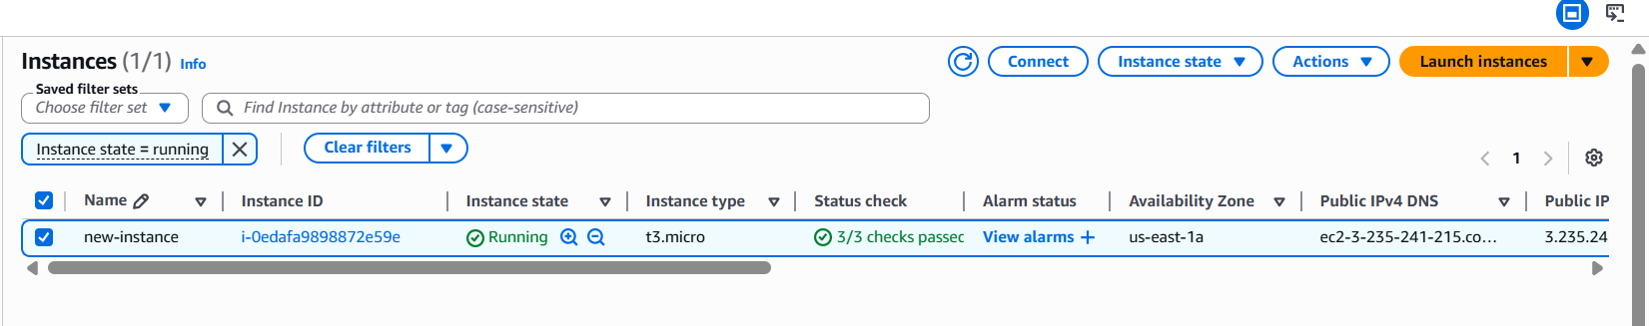
Installed apache web server
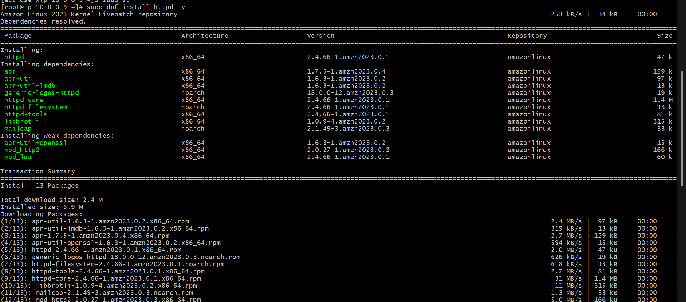
Created a new sample web page and verify it
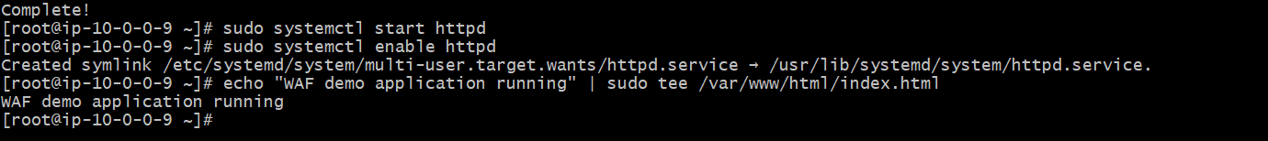
New application load balancer
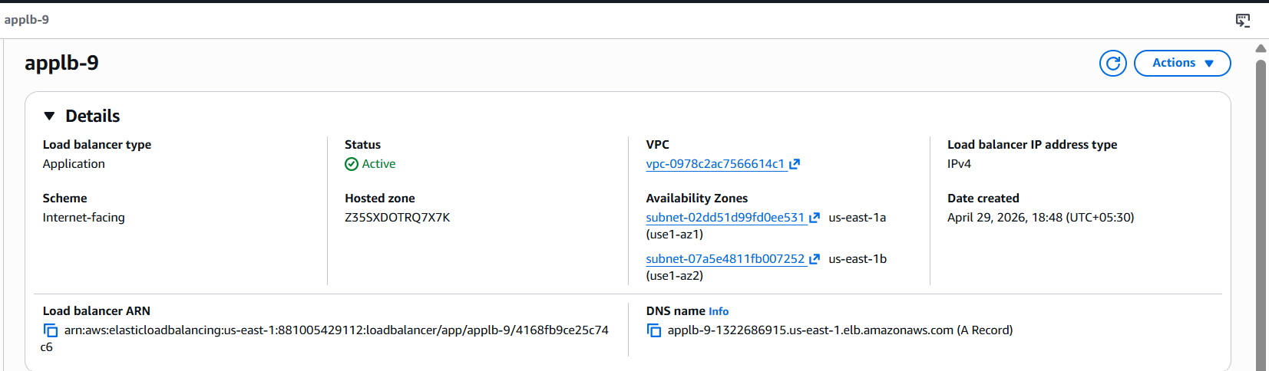
Created target group
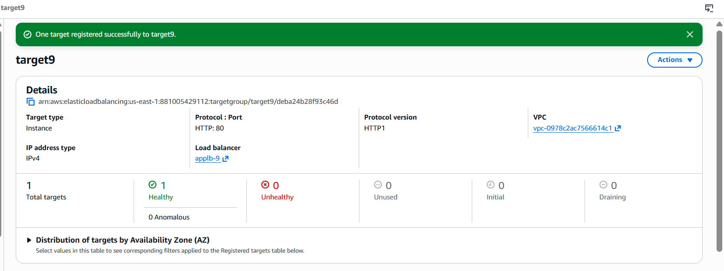
Verified ALB working
Created web ACL
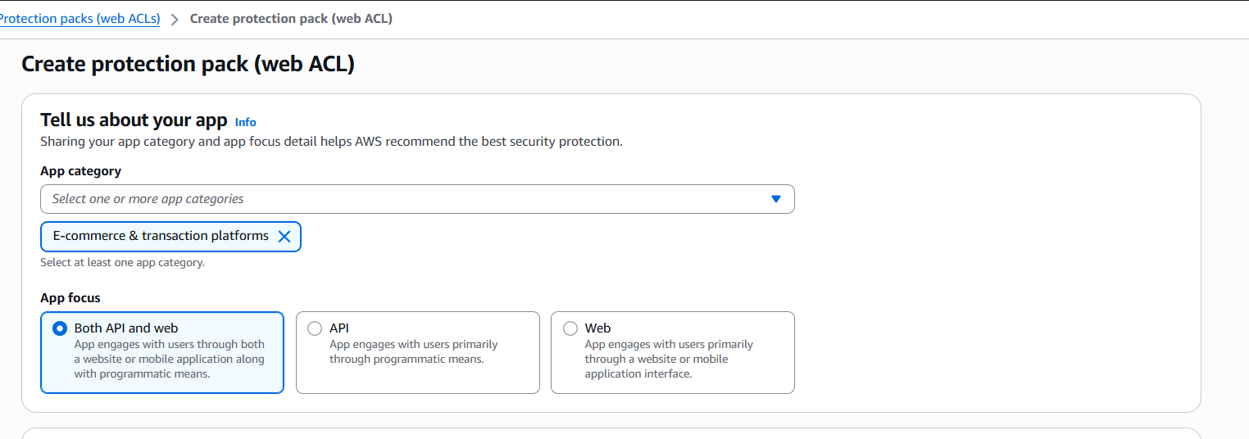
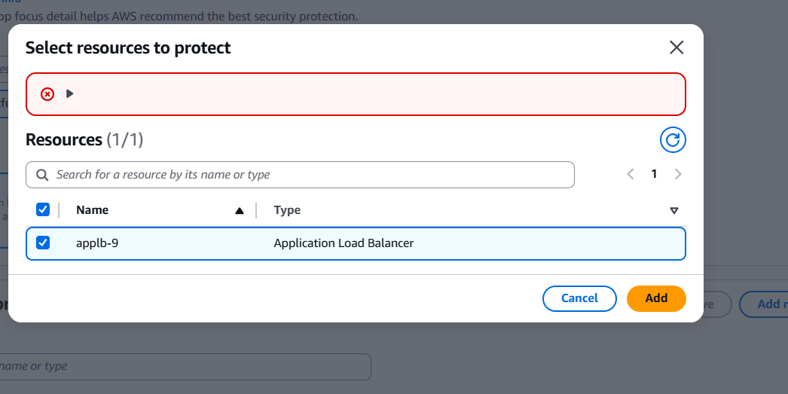
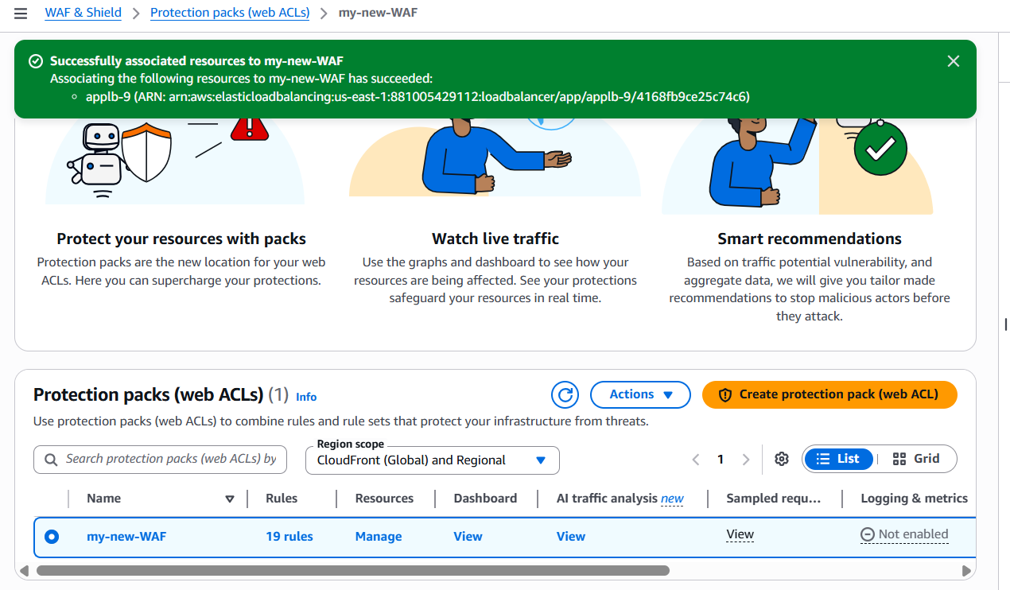
Check DNS of load balancer still active or not
Now test malicious request
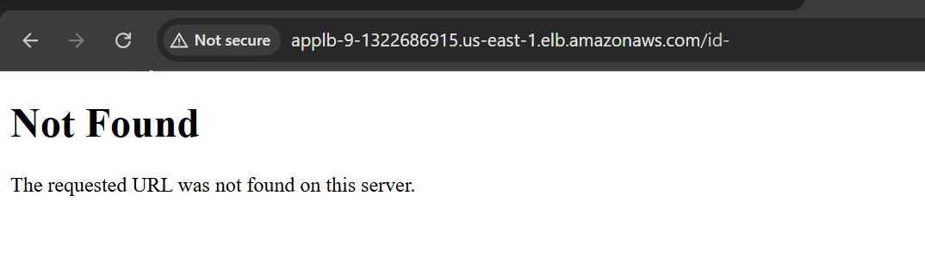
Verify in WAF Logs in dashboard

